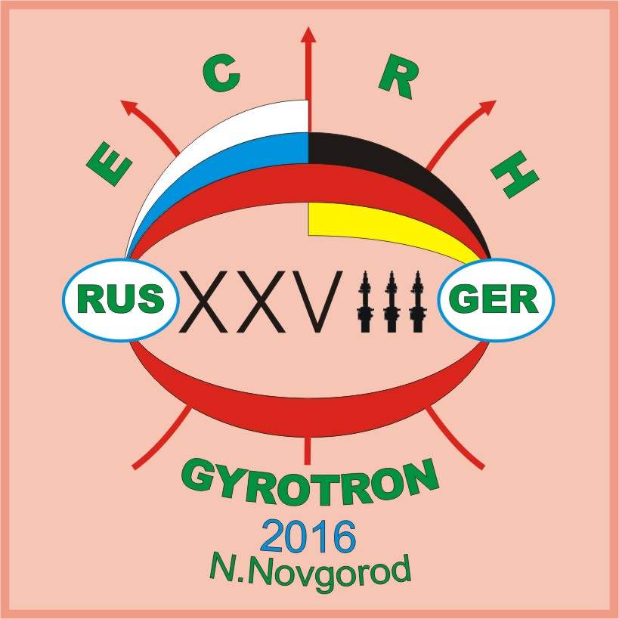
28th Joint Russian-German Meeting on ECRH and Gyrotrons
June 27-July 3

IAP RAS, Nizhny Novgorod (June 27-July 3), Seminar Room

General Programme

Sunday, June 26 | Arrival of the German delegation to Nizhny Novgorod
Monday, June 27 | 9.20 Welcome and Opening  9.30 Workshop (Gyrotrons, ECRH, ECCD))  13.00 Lunch break  14.30 Workshop (Gyrotrons, ECRH, ECCD)
Tuesday, June 28 | 9.30 Workshop (Gyrotrons, ECRH, ECCD, Plasma Diagnostics)  13.00 Lunch break  14.30 Workshop (Gyrotrons, ECRH, ECCD, Plasma Diagnostics)
Wednesday, June 29 | 9.30 Workshop (Transmission Systems, Gyrotrons, Material Processing,)  13.00 Lunch break  14.30 Workshop (Transmission Systems, Windows, Material Processing,)  18.00 Reception
Thursday, June 30 | 9.30 Discussion &Excursion
Friday, July 1 | 9.30 Workshop (Gyrotrons, FEL, ECRH, ECCD, Plasma Diagnostics)  13.00 Lunch break  14.30 Laboratory visit at IAP RAS  16.30 Workshop (Gyrotrons, FEL, ECRH, ECCD)
Saturday, July 2 | 9.30 Workshop (ECRH, ECCD, Gyrotrons, DNP NMR)  13.00 Lunch break  14.30 Discussion, elaboration and approval of concluding documents.
Sunday, July3 | Departure of the German delegation from Nizhny Novgorod

Мероприятие проводится при финансовой поддержке Российского фонда фундаментальных исследований: Проект № 16-02-20374.

www.ecrh.iapras.ru

28th Joint Russian-German Meeting on ECRH and Gyrotrons
June 27-July 3

IAP RAS, Nizhny Novgorod (June 27-July 3), Seminar Room

Scientific Programme
Monday, 27 June 2016.

9.20 | Welcome and Opening (Prof. A.G.Litvak, Prof. H.Zohm).
9.30 | J. Jelonnek, (KIT, IHM, IHE): 2016 status of gyrotron research at KIT.
10.00 | G.G.Denisov (IAP/GYCOM/IPT): Status of 170GHz/1MW Gyrotron for ITER
10.30 | F.Wilde (KIT): An Approach to an Electronic Stability Control for Gyrotrons.
11.00 | Coffee break
11.30 | H. Zohm (IPP): ITER-DEMO-FPP, a stepladder strategy to Fusion Energy.
12.00 | A.G Shalashov, et al. (IAP, BI NP, NSU): Recent status of ECRH and ECE experiment at the GDT mirror trap.
12.30 | D. Wagner (IPP): Status of the ECRH System at ASDEX Upgrade (25 min. + 5 min. discussion)
13.00 | Lunch break
14.30 | E.Z.Gusakov, А.Yu. Popov (Ioffe Institute) Anomalous absorption and backscattering in the second harmonic X-mode ECRH experiments as result of low-threshold two-UH-plasmon decay.
15.00 | S.Ruess et al. (KIT): Ongoing developments for the KIT 2-MW 170-GHz Coaxial Cavity Gyrotron Prototype
15.30 | P.V.Savrukhin, et al. (TPI NRC KI) Disruptions and runaway mitigation using ECRH and inductive power supply systems in the T-10 tokamak.
16.00 | Coffee break
16.30 | P.V. Minashin, et al. (TPI NRC KI): Synergetic effects for electron cyclotron (EC) radiation in a tokamak reactor: interference of internal EC power loss and external EC resonance heating.
17.00 | A.A.Balakin, et al. (IAP) Advanced quasi-optics for wave beams in smoothly inhomogeneous dispersive and dissipative media.
17.20 | S.N.Vlasov, E.V.Koposova (IAP) The maximum factor of transmission of energy through smoothly inhomogeneous medium.
17.40 | Discussion.

28th Joint Russian-German Meeting on ECRH and Gyrotrons
June 27-July 3

IAP RAS, Nizhny Novgorod (June 27-July 3), Seminar Room

Scientific Programme
Tuesday, 28 June 2016

9.30 | T.Stange (IPP): First ECRH plasmas in the Wendelstein 7-X Stellarator
10.00 | E.A.Soluyanova et al. (Gycom, IAP): Experimental results of new two-frequency cw gyrotron system.
10.30 | A.I.Tsvetkov, et al. (IAP, GYCOM) Development of 45 GHz/20 kW gyrotron based setup for ECR ion source.
11.00 | Coffee break
11.30 | V.O.Nichiporenko, et al. (GYCOM): The Predicted Lifetime of Thermally Loaded Units of Gyrotrons.
12.00 | D.Moseev (IPP): Prospects of ion temperature measurements by CTS in Wendelstein 7-X.
12.30 | S.Marsen (IPP): ECRH Protective Diagnostics: Experience from the first experimental campaign of Wendelstein 7-X.
13.00 | Lunch break
14.30 | N.S.Ginzburg, et al. (IAP) Generation of train of powerful ultrashort pulses in electron devices with passive mode-locking.
15.00 | Stefan Marsen (IPP): Upgrade of the fast interlock and control system of the Wendelstein 7-X ECRH plant.
15.30 | E.B Abubakirov, et al. (IAP). Experimental realization of pulsed 3-mm relativistic gyrotron with multi-megawatt output power.
16.00 | Coffee break
16.30 | A.S.Zuev, A.S.Sedov, et al. (IAP): Multi-frequency sub-terahertz gyrotrons for spectroscopy and plasma diagnostic.
16.50 | A.V.Arzhannikov, et al. (BINP, NSU, NSTU): GOL-PET experiments on directed output of 0.5 THz emission from REB-plasma system.
17.20 | Discussion

28th Joint Russian-German Meeting on ECRH and Gyrotrons
June 27-July 3

IAP RAS, Nizhny Novgorod (June 27-July 3), Seminar Room

Scientific Programme
Wednesday, 29 June 2016

9.30 | P.Späh (KIT): Integration of ITER Upper Launcher In-Vessel Microwave components.
10.00 | N.K.Kharchev, et al. (IAP, GPI) Quasi-optical components for ECR system of stellarator L-2M.
10.30 | C. Lechte, et al. (IVGP, IPP): Remote-Steering Antennas for 140 GHz electron cyclotron heating of the Stellarator W7-X.
11.00 | Coffee break
11.30 | D.I.Sobolev et al. (IAP): Wideband miter bends for HE11 mode of circular corrugated waveguide.
11.50 | V.E.Zapevalov. (IAP): Non-canonical Gyrotrons.
12.10 | M.Yu.Glyavin, et al. (IAP, NNSU, FIR FU) Development of a Second Harmonic Double-Beam Continuous Wave Gyrotron with Operating Frequency of 0.79 THz.
12.30 | S.V.Egorov, et al. (IAP; DIChHPS): Millimeter -wave sintering of low loss MgAl₂O₄ Ceramics.
13.00 | Lunch break
14.30 | T.Scherer (KIT): Recent Developments in ECRH window Technology.
15.00 | M.A.Lobaev, et al. (IAP, IPMS): Recent development of semiconductor CVD diamond growth.
15.30 | V.I.Malygin, et al. (IAP, GYCOM, IPP): Status of multi-frequency gyrotron window and recent test results.
16.00 | V.V.Parshin and E.A.Serov (IAP): Silicon-Carbide as the materials for high-power electronics and microelectronics.
16.30 | Discussion.

28th Joint Russian-German Meeting on ECRH and Gyrotrons
June 27-July 3

IAP RAS, Nizhny Novgorod (June 27-July 3), Seminar Room

Scientific Programme
Thursday, 30 June 2016

9.30 | Discussion & Excursion

28th Joint Russian-German Meeting on ECRH and Gyrotrons
June 27-July 3

IAP RAS, Nizhny Novgorod (June 27-July 3), Seminar Room

Scientific Programme
Friday, 1 July 2016

9.30 | S.L.Sinitsky, et al. (BINP, NSU, IAP): Generation of 75 GHz radiation pulses by two-channel planar FEM at weak and strong coupling.
10.00 | W. Kasparek, et al. (IVGP, IPP, IAP, NIFS): Millimeter Wave Components for Collective Thomson Scattering Experiments.
10.30 | E.V.Koposova, et al. (IAP, NIIIS): Quasioptical three-mirror traveling –wave echelette cavity with frequency tuning: diffraction theory and experiment.
11.00 | Coffee break
11.30 | C. Lechte, et al, (IVGP, IPP): Simulation of Doppler Reflectometry for Wavenumber Spectra.
12.00 | V.A. Skalyga, et al. (IAP) High current ECR ion source with gyrotron plasma heating for neutron generators.
12.30 | I.S.Abramov, et al. (IAP): The stationary microwave discharge in the expanding gas flow as a source of EUV radiation.
13.00 | Lunch break
14.30 | Laboratory visit at IAP RAS.
16.00 | Coffee break
16.30 | I.V.Zotova, et al. (IAP ) Generation of ultrashort microwave pulses based on Cherenkov superradiance from high-current electron bunches (power and frequency increasing).
16.50 | V.N.Manuilov and V.E.Semenov. (NNSU, IAP) Ion compensation of the space charge in the gyrotron helical electron beams.
17.10 | K.A.Lesheva, et al. (NNSU, IAP) Nonadiabatic electron-optical system for the formation of high quality helical electron beam.
17.30 | M.I.Petelin, M.K.A.Thumm (IAP, KIT): Ups and downs of the ether.

28th Joint Russian-German Meeting on ECRH and Gyrotrons
June 27-July 3

IAP RAS, Nizhny Novgorod (June 27-July 3), Seminar Room

Scientific Programme
Saturday, 2 July 2016

9.30 | J.Stober (IPP, Garching) Advanced Tokamak Experiments in W-coated ASDEX Upgrade.
10.00 | Yu.V.Novozhilova et al. (IAP): Influence of mode competiton on frequency locking of multimode gyrotron by external monochromatic signal.
10.20 | A.V.Savilov et al. (IAP): The use of quasi-regular cavities with wave phase correctors in high-harmonic gyrotrons.
10.40 | M.A.Khozin, et al. (IAP): Improving the efficiency of Bragg reflectors.
11.00 | Coffee break
11.30 | F.Engelke et al. (Bruker) :Dynamic nuclear polarization at low temperatures and fast sample spinning.
12.00 | A.P.Fokin, et al. (IAP): Power and frequency control in gyrotrons for spectroscopy and materials processing.
12.30 | A.E.Fedotov, et al. (IAP): Project of a compact low-voltage gyrotron for DNP designed for operation in NMR spectrometer magnet.
13.00 | Lunch break
14.00 | Discussion, elaboration and approval of concluding documents.

